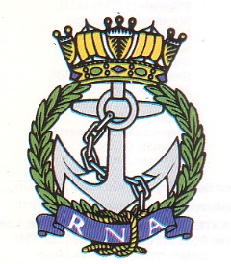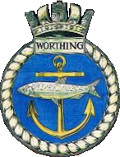
Once Navy Always Navy
Royal Naval Association
Worthing Branch

Annual General Meeting
Agenda
Thursday 19th February 2026 1900Hrs

Members Attending: Shipmates:

Apologies for Absence: Shipmates:

- Branch Chairman welcomes Shipmates to the 2026 AGM

- Branch Chaiman proposes the Loyal Toast.

- Minutes of the Annual General Meeting 2025

Proposed, Seconded, Vote

- Previous Meeting and Matters arising

- Branch Reports

Chairman’s Report, Secretary’s Report, Treasurer’s Report, Welfare Officer’s Report, Standard Bearer’s Report, Public Relations Officer Report, TS Vanguard Report, Membership report, Area Rep’s report.
- Adoption of Reports
Vote

- Branch Secretary Election of Branch Officers.

For election Branch Vice Chair, Branch Secretary, Branch Treasurer, Events Coordinator.
Proposed, Seconded, Vote

There being no further business the 2026.

AGM closed at

